A Survey on Image Pre-processing Techniques for

Medical Imagery

[*29861it@gmail.com*](mailto:29861it@gmail.com)

*Ria Kalra (B.Tech, IT-II) PSIT, Kanpur*

*2101640130061*

***Abstract-* A Digital Image is an image composed of pixels, each with finite, discrete units for numeric representation for its intensity.Image enhancement is one of the most complex and important tasks in digital image processing. Image enhancement**

**Pre-processing techniques are used in improving the visual quality of images. The majority of applications, including radiography, MRI, ultrasound imaging, tomography, fundus imaging, and now use medical imaging. Contrast and Image quality are the major issues in medical imagery. Image Enhancement techniques makes the image more clear for human perception or machine analysis. The process of Image enhancement doesn't raise the inbuilt information content of the data, but can highlight the features of interest to detect the objects in a simple and efficient manner for accurate results.**

**I. INTRODUCTION**

With the rapid increase of the application of Digital Imaging in the field of medicine, it has raised the need for the implementation of suitable algorithms for processing of Images in detection, Screening and classification of diseases. Medical images are affected by noise, blurriness, poor contrast and sharpness which may results in false diagnosis .There are different types of imaging techniques depending on the application it serves.

1. X-ray methods of medical imaging include conventional X-ray, computed tomography (CT) and mammography.

2. Molecular imaging uses a variety of methods to visualize biological processes taking place in the cells of organisms.

3. Fundus imagery used to image the retina of eye in screening of Diseases like glaucoma and Diabetic Retinopathy.

4. Other types of medical imaging include Magnetic Resonance Imaging (MRI), Cardiograph and ultrasound imaging.

**II. IMAGE ENHANCEMENT**

Image enhancement techniques are the following:--

A. MORPHOLOGICAL OPERATIONS

Morphology is a broad set of image processing operations that process images based on shapes. Morphological operations apply a structuring element to an input image, creating an output image of the same size. In a morphological operation, each image pixel is corresponding to the value of other pixel in its neighbourhood.

The most basic morphological operations are dilation and erosion. Dilation adds pixels to the boundaries of objects in an image, while erosion removes pixels on object boundaries. The number of pixels added or removed from the objects in an image depends on the size and shape of the structuring element used to process the image. In the morphological dilation and erosion operations, the state of any given pixel in the output image is determined by applying a rule to the corresponding pixel and its neighbours in the input image. The rule used to process the pixels defines the operation as a dilation or an erosion.

Steps to Process Image:

1. Import necessary libraries

from skimage import morphology

import matplotlib.pyplot as plt

1. Load the original image
2. Determine a threshold
3. Create binary image
4. Apply erosion to binary image
5. Apply dilation to binary image
6. Plot the original , dilated and eroded images

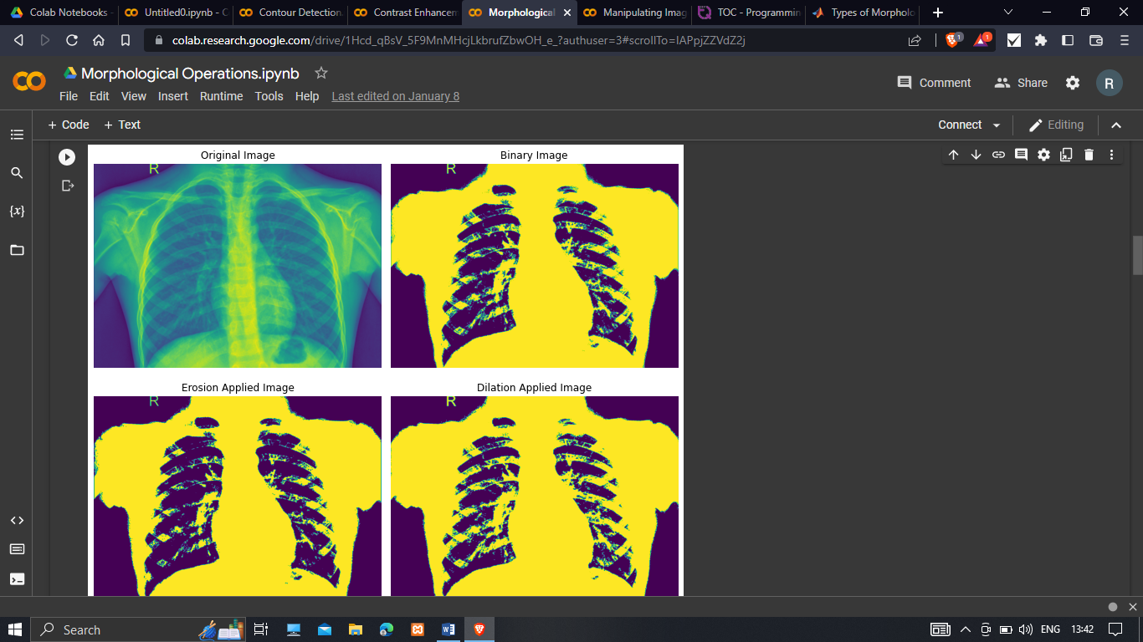

1. Denoise the image and determine a threshold
2. Create binary image
3. Create structuring element
4. Apply opening
5. Apply closing
6. Plot the original, binary, opened and closed images.

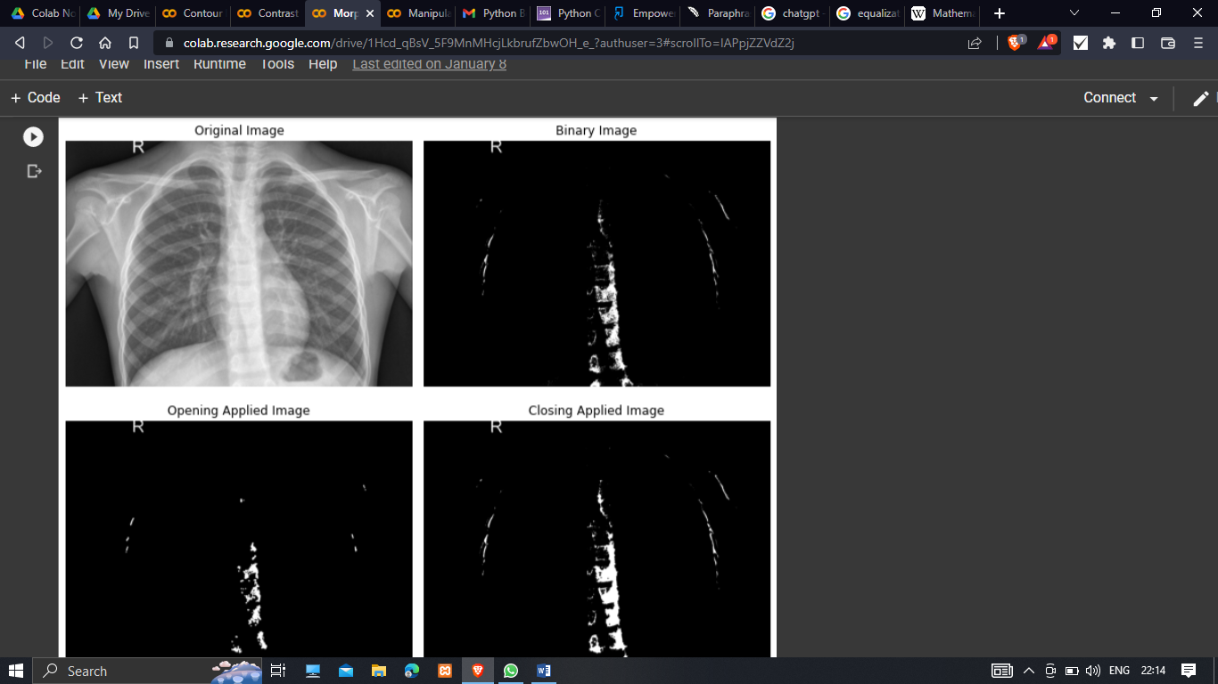

1. Load the image into the workspace
2. Turn the image to grayscale
3. Denoise the image
4. Apply threshold of 0.3 to image
5. Plot the grayscale, filtered and binary images.

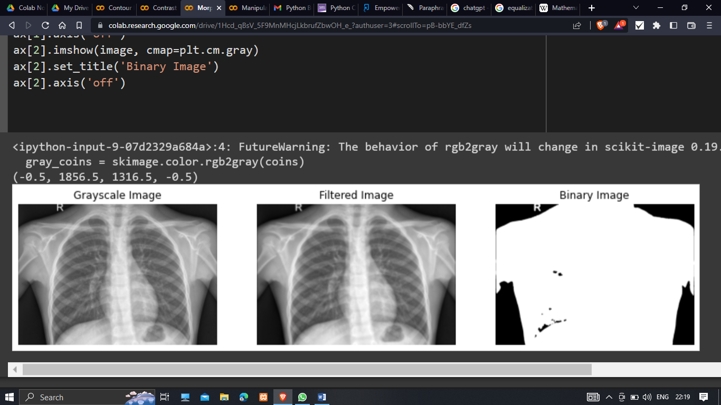



1. Create a structuring element
2. Apply binary erosion to image

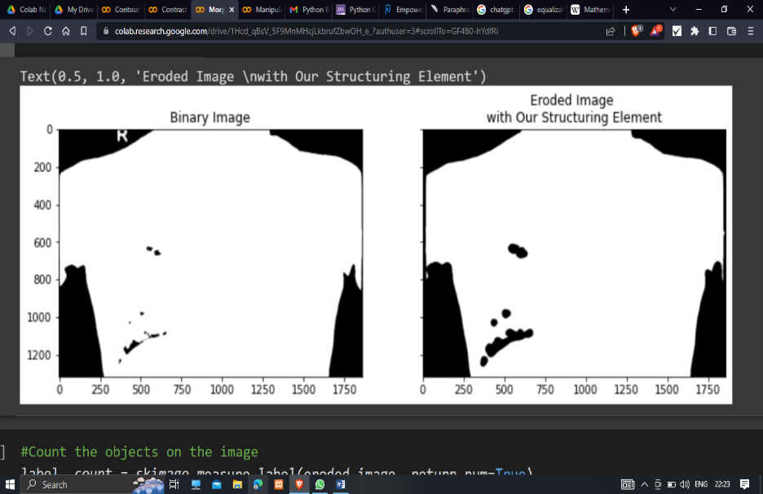

B CONTRAST ENHANCEMENT

The aim of this study is to improve the image quality, enhance features and gain better characteristics of s medical images for accurate diagnosis.

Contrast enhancement is a significant factor in any subjective evaluation of image quality which used to enhance the overall quality of the medical image for feature visualization and clinical measurement.

Several techniques are existing to improve the contrast and brightness of an image. The histogram modification techniques have been widely used for enhancing the contrast of medical image. The histogram equalization (HE) is one of the most popular technique which frequently used due to its simplicity and explicitness.

Histogram Equalization is a method to process images to adjust the contrast of image by changing the intensity distribution of histogram.

1. Load and display the image

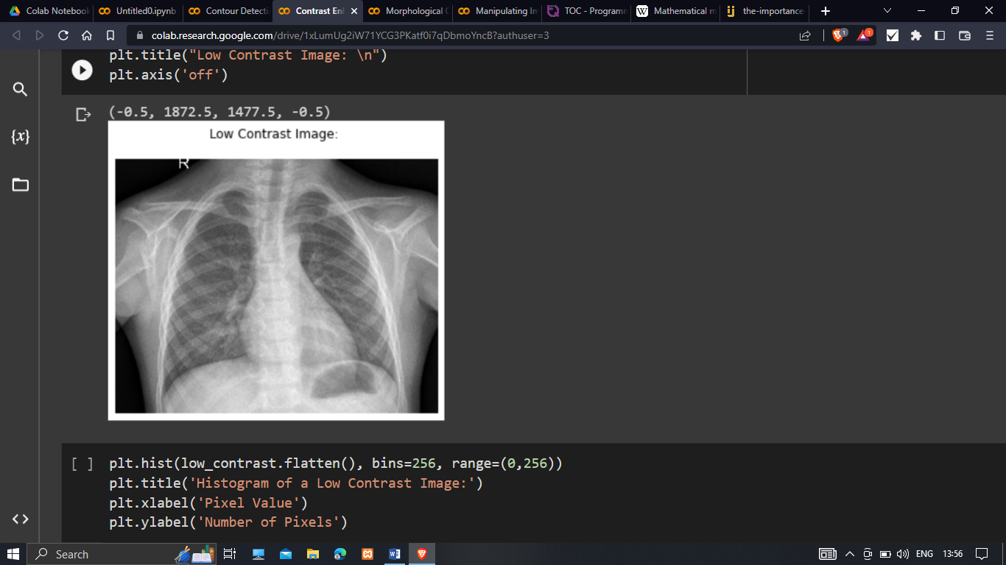

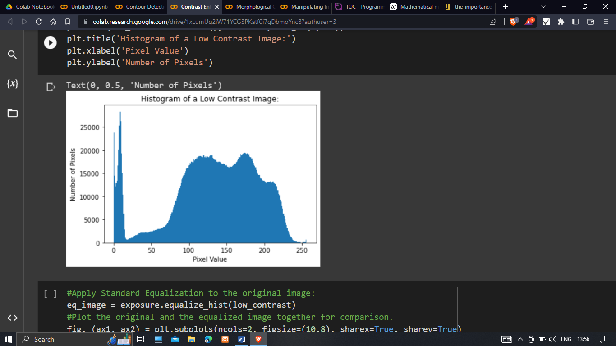

ii Apply standard equalization to the original image

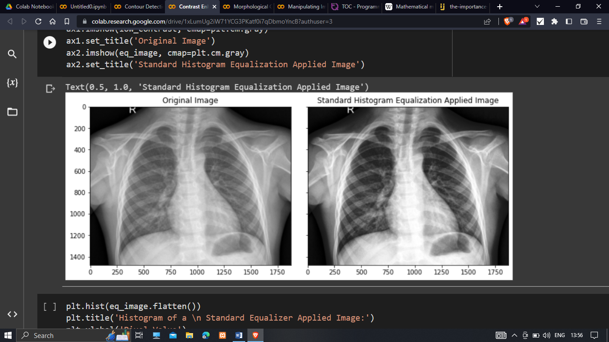

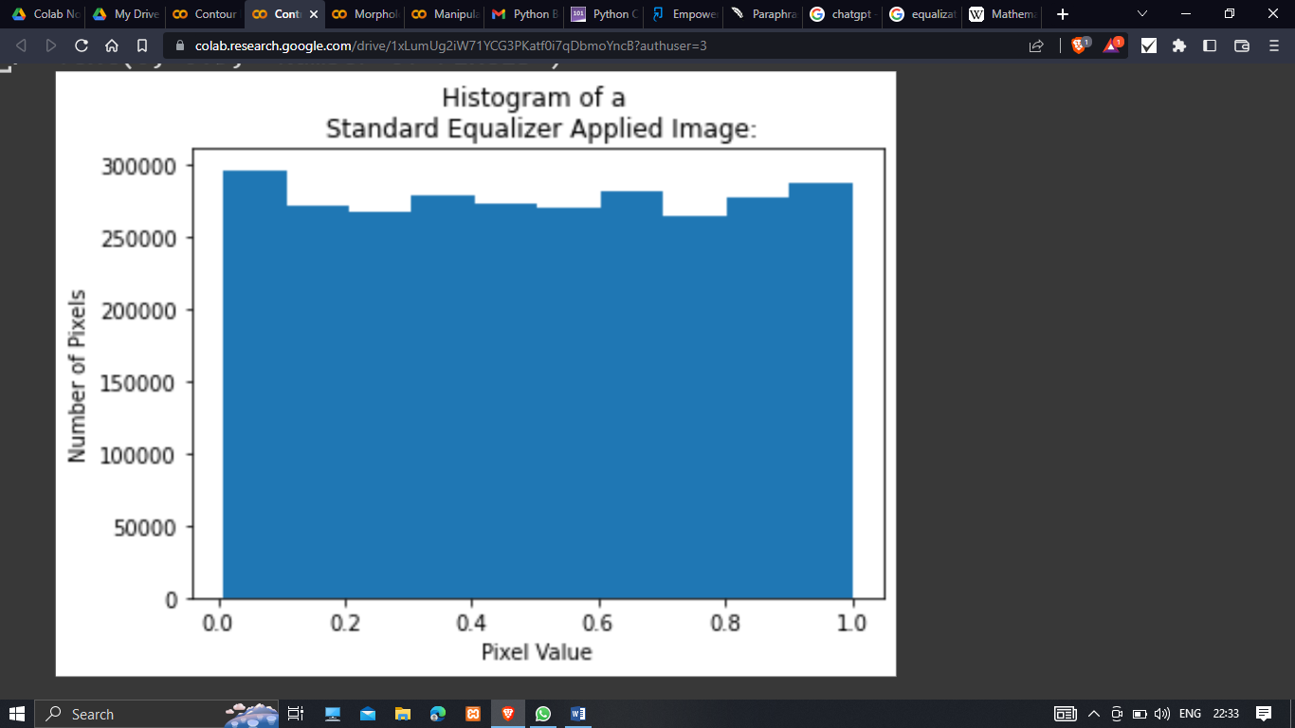

iii Apply standard and adaptive equalization to original image.

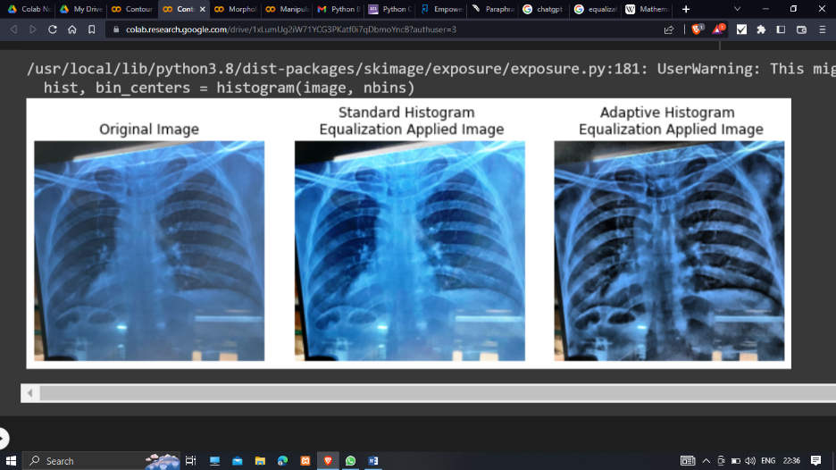

C CONTOUR DETECTION

Contours are defined as the line joining the boundary of the image that are having the same intensity. They come handy in shape analysis, finding the size of the object and object detection. We can easily detect the borders and locate them easily in an image.

It is an outline especially for curving or irregular figure.

Contours are imaginary line that connects points of equal value.

Steps to find Contours in an image:

i Import necessary libraries

from skimage import morphology

import matplotlib.pyplot as plt

from skimage.filters import Gaussian

from.measure import find_contours

ii Load the original image

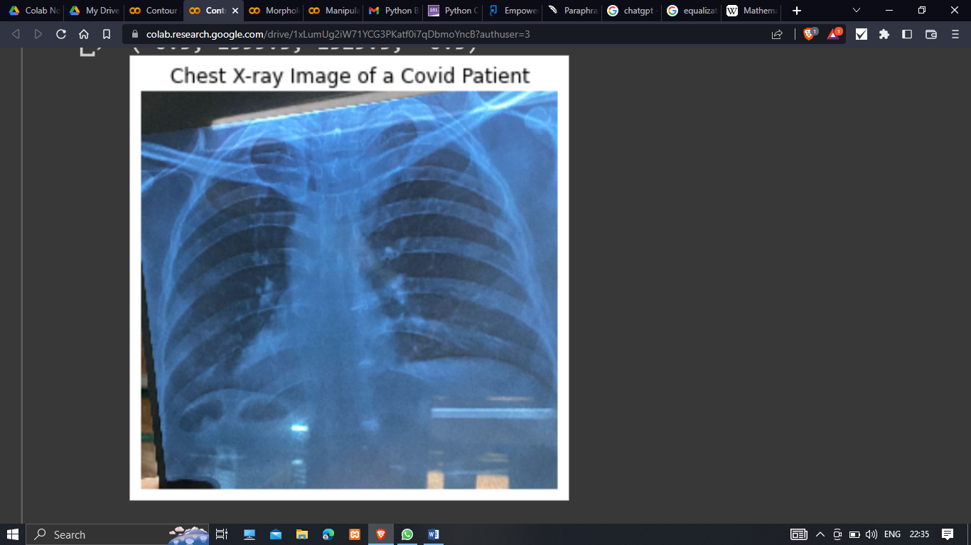

iii Produce the grayscale image and denoise it.

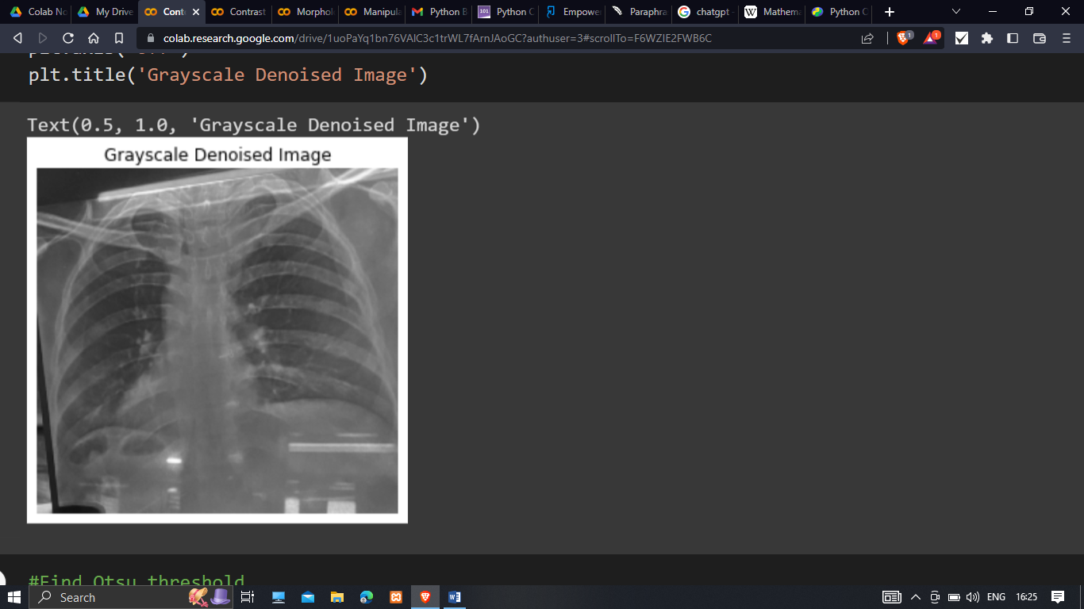

iv Find the Otsu threshold and create a binary mask where holes are white and rest is black.

(Otsu’s method is used to perform automatic image thresholding. It returns a single intensity threshold that separates pixels into two classes, background and foreground)

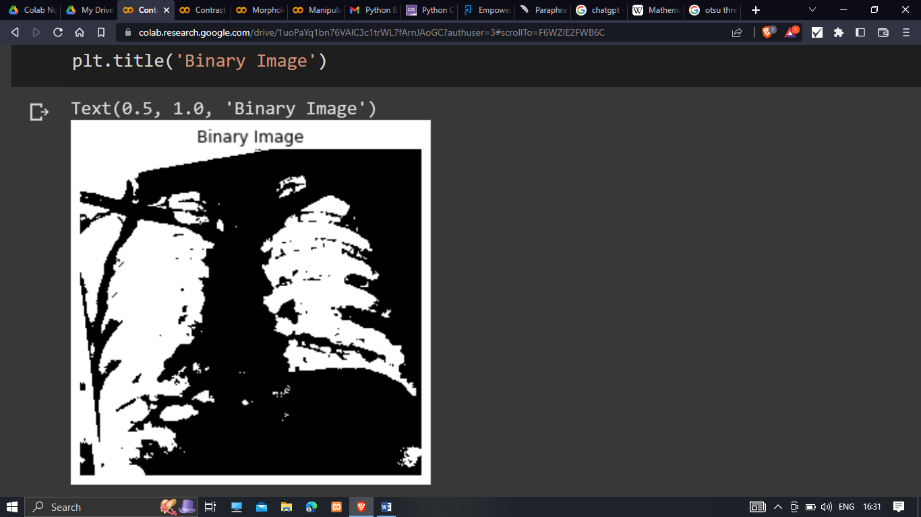

v Plot the contours

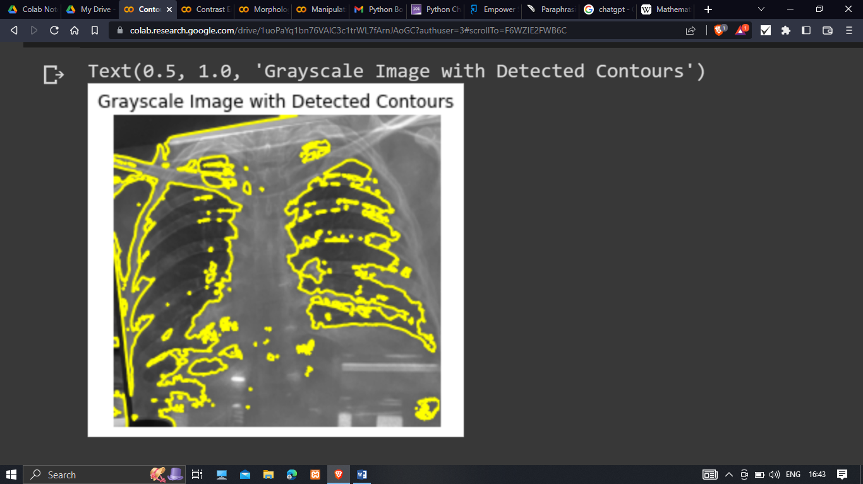

D MANIPULATING IMAGE PIXELS

A pixel is a smallest unit (or grids) that forms an image on a computer screen. Images are stored as an array of pixels.

Each pixel has a color.

The primary aim of image manipulation is to enhance the appearance of the image.

The advantages of image manipulation are:

* Photo-intensive tasks become easier
* Reuse images for better efficiency
* Easy multi-platform customization

Steps to manipulate image pixels:

i Import necessary libraries

import matplotlib.pyplot as plt

import skimage.io

import numpy as np

ii Load the image in grayscale

iii To avoid dealing with numbers,

array elements values are multiplied by 100

image = original_image*100

iv Make manipulation on the copy of the image

image_copy = image.copy()

v Set pixels with values less than 50 to 0

image[image_copy<50]=0

vi Set pixels with pixels greater than 20 to 100

image[image_copy>20]=100

vii Plot the original, and the manipulated images

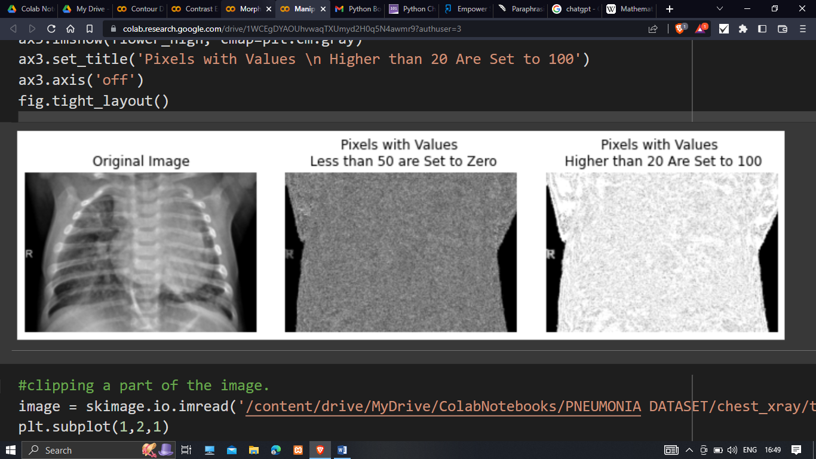



viii Clipping the part of the image

image = skimage.io.read(“image_link”)

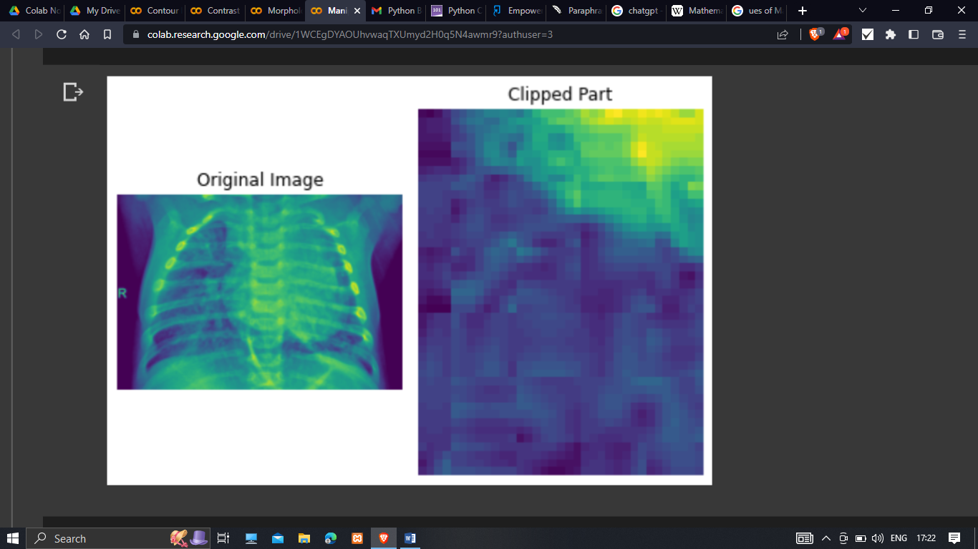

Ix Find color at this pixel and display the color values

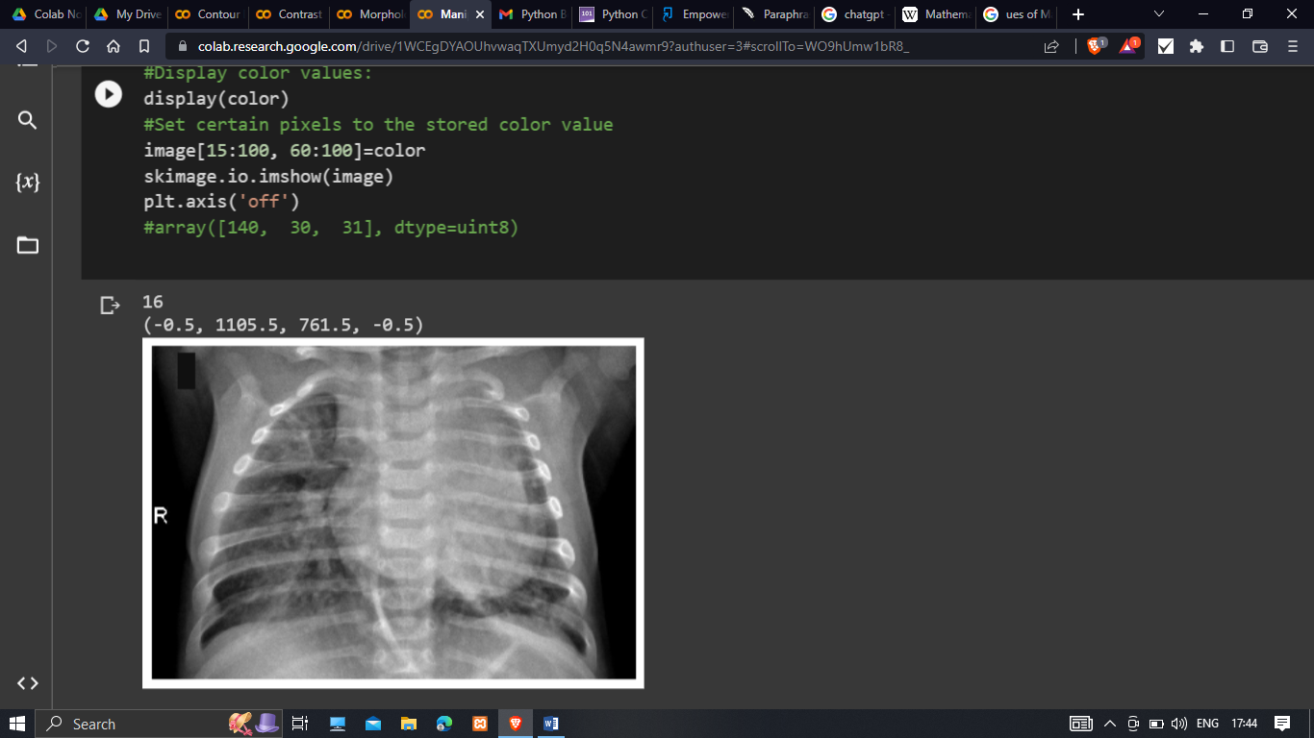

**III LITERATURE REVIEW**

 Baudoin et al. are one the first researchers that worked on MA detection in 1983 using fluorescein angiogram images. They employed a mathematical morphology-based approach to remove vessels and applied a top-hat transformation with linear structuring elements. Several methods followed this approach.[3]

Imagemanipulatio*n*. It can read in images, in a variety of file formats, manipulate them in terms of brightness, contrast and colour, or smooth and enhance lines. However, the primary aim of an image manipulation package is to enhance the appearanceof an image. An image analysis software, on the other hand, is designed to quantify the content of an image.

The aim of this study is to improve the image quality, enhance features and gain better characteristics of several medical images for a precise analysis and diagnosis.

**IV CONCLUSION AND DISCUSSIONS**

This paper presents a taxonomy of the image pre-processing techniques. We attempt to distinguish the following categories. The first one, morphological operations approach, creates output image of same size, adding boundaries to the image. The second one, contrast enhancement approach, improves image quality, enhance features. The third one, contour detection approach, detect borders and localise them in an image. The fourth one is manipulating image pixels approach, to enhance the appearanceof an image in terms of brightness, sharpness, contrast and color.

Contour detection is of theoretical and practical significance and focuses mainly on “edge and line oriented approaches”. Specially, deep learning techniquesare successfully applied to solve the problem of contour detection.

This paper can provide a clear idea on pre-processing techniques of images for the further steps on image processing.

ACKNOWLEDGEMENTS

This paper and research behind it would not have been possible without the extraordinary support and motivation of my supervisor Mr.Piyush Bhushan (HOD) IT, PSIT. His knowledge and exacting attention to details have been an inspiration and kept my work on track from my first encounter to the final draft of this paper.

**References**

1. Google Colab <https://colab.research.google.com/drive/1T7t324thWAqpWkNLoaDsgCz2tjvlJRy3?authuser=3>
2. <https://en.wikipedia.org/wiki/Mathematical_morphology>
3. <https://www.ijert.org/research/the-importance-of-contrast-enhancement-in-medical-images-analysis-and-diagnosis-IJERTV7IS120006.pdf>
4. mi-research.net
5. [www.sciencedirect.com](http://www.sciencedirect.com)
6. [www.researchgate.net](http://www.researchgate.net)

ome of the most popular methods for Pneumonia detection, currently, include Sputum tests, Blood tests and CT Scan.

Methods like Blood tests take longer time to give out results. Whereas, methods like Sputum test is comparatively inaccurate and

lastly, methods like CT Scan are very expensive for a common man. These factors inspired us to consider this project where a

patient can get a rough idea about his health, thus decreasing costs for common man and number of tests required.

ome of the most popular methods for Pneumonia detection, currently, include Sputum tests, Blood tests and CT Scan.

Methods like Blood tests take longer time to give out results. Whereas, methods like Sputum test is comparatively inaccurate and

lastly, methods like CT Scan are very expensive for a common man. These factors inspired us to consider this project where a

patient can get a rough idea about his health, thus decreasing costs for common man and number of tests required.